WEB DEWEY Beginners tutorial

I. Small group tutorial – I

Review of logging on
Review of general structure of WebDewey
Drilling down through the summaries
The search option
The browse option
Tables
The structure of built numbers
Building simple numbers

A. Logging on

http://dewey.org/webdewey/

Authorization: “Your Authorization”
Password : “Your Password.”
If you use Firefox, it is easy to save your settings as a cookie, so you don’t have to enter your password each time.
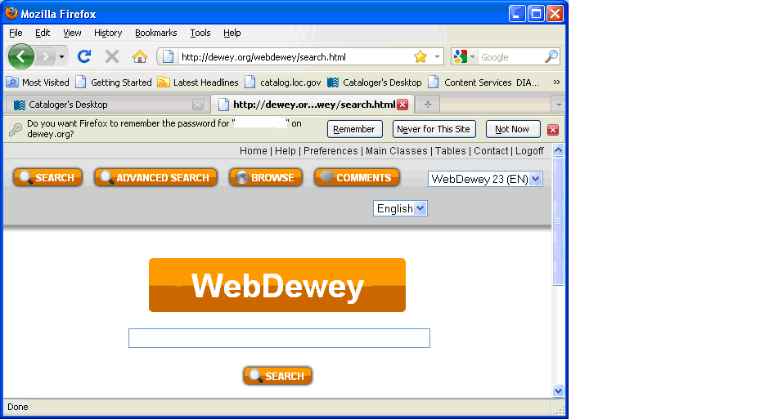

To save your password and ID, click on “Remember” when you see the message “Do you want Firefox to remember the password for “Your Authorization” on dewey.org”?

Once you have logged in, by default you are using the 23rd edition of Dewey, which has an orange menu bar.

For now, however, we will be looking at the DDC22 classification, which is still available by clicking on the drop down box at the top right hand side of the screen.

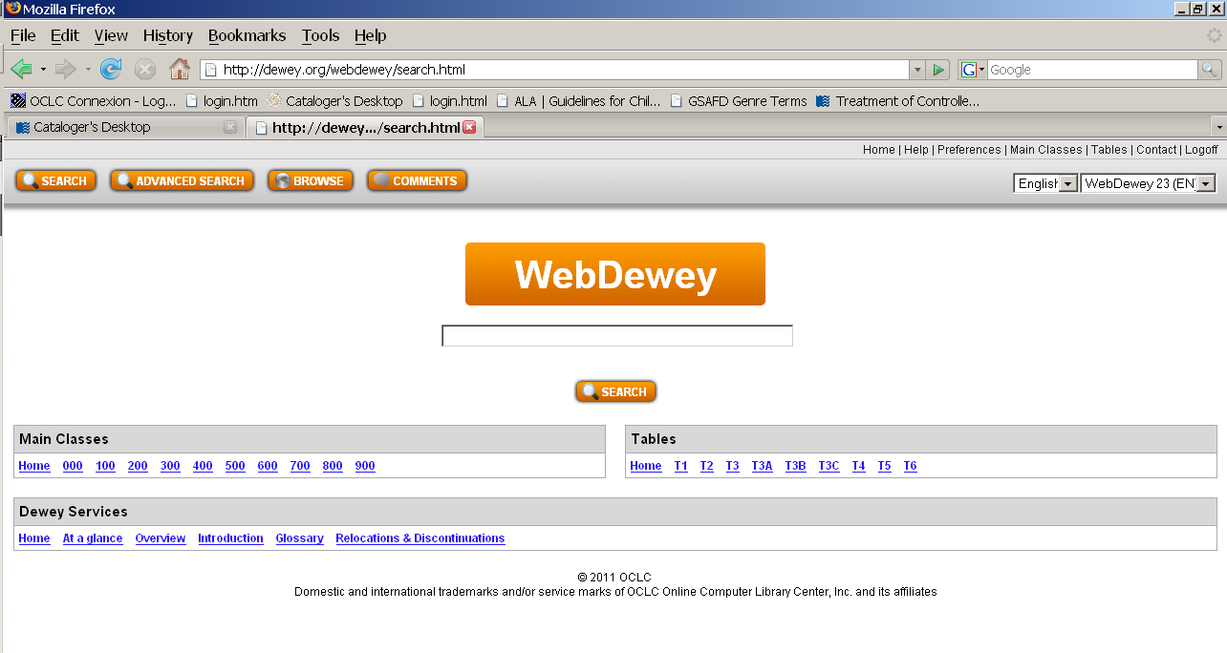
Review of introductory screen – summaries, tables, introduction.
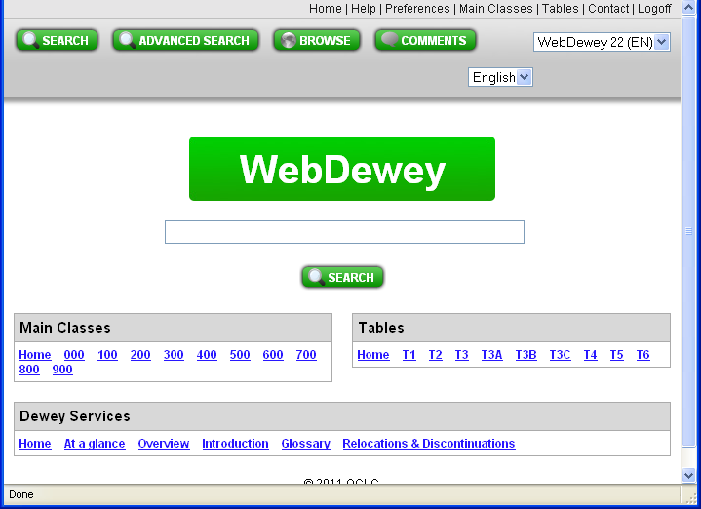

NB
- The summaries are not complete in WebDewey 22 in the 500 class (580 and 590 are missing). This has been fixed in WebDewey 23
- You cannot directly search or browse the Manual. To find instructions in the manual, you need to do a general search, and Manual entries in your results will appear with a “M” in front

B. Review of general structure
Broader numbers
Box to build numbers
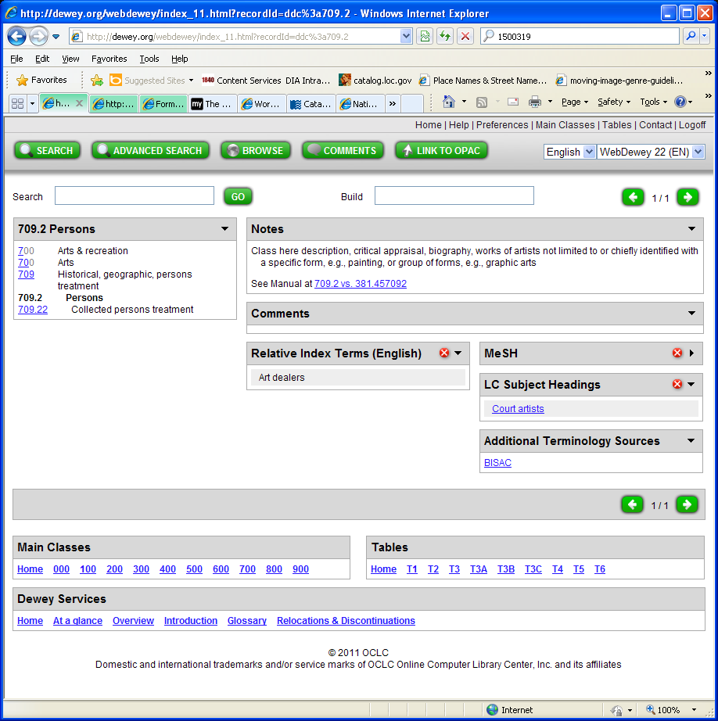
Narrower numbers

Tables
LC subject headings associated with the Dewey number
Class summaries

There are fewer LC subject headings linked into this interface than in the previous WebDewey. Only the “editorially mapped” headings have transferred across, so the headings displayed may be much narrower than the actual scope of the number – e.g. court artists is much narrower than artists.

C. Finding a number by drilling down through the summaries

This approach helps you consider discipline and how numbers fit within the overall structure of Dewey

Consider a general work about costume.

- Click on the “Home button” to open the Main Classes
- Costume could fit under either 300 Social Sciences or 700 Arts and recreation
- Right-click on 300 to open in a separate tab
- Click on 390 Customs, etiquette & folklore
- Click on 391-394 - Customs
- Click on 391 – Costume and personal appearance

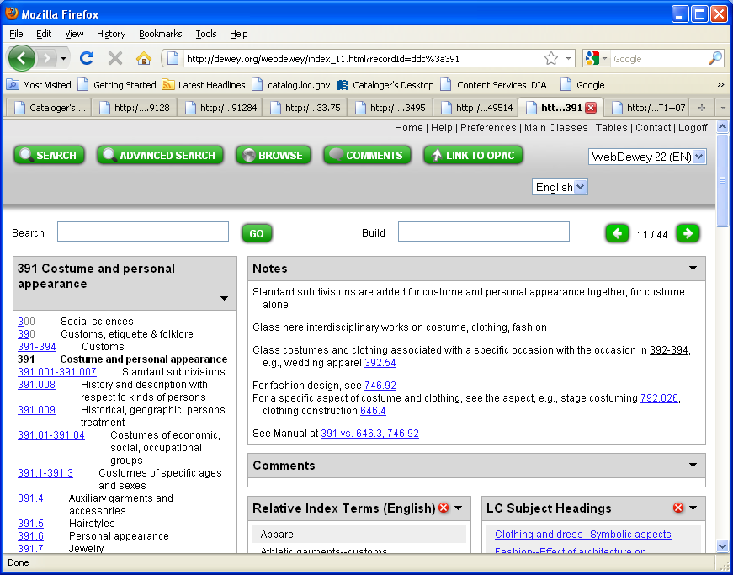
g) Right-click to open manual note under 391 vs. 646.3, 746.92

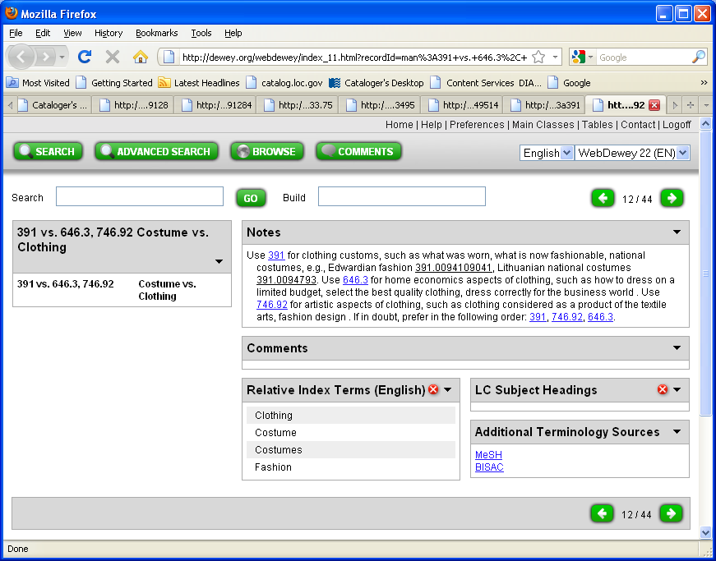

This confirms that 391 is the appropriate number for Clothing customs

D. Review of Browse option

The browse option is useful if:

- you already have a Dewey number and would like to check it

- you have decided on a general Dewey number, and wish to drill down to find a more specific number.

- to narrow your search by browsing the Relative index. This is especially useful if your keywords are quite general, as if you do a keyword search, you are likely to get hundreds of results.

For example, click on the box at the top of the screen next to the “Browse” button. In the box, enter Peace. Click on the drop down menu option for “Relative Index”, and then click on Quick Browse.

You will see a long list of terms all starting with Peace.

The interdisciplinary number always appears first in the relative index. The interdisciplinary number for peace is 303.66

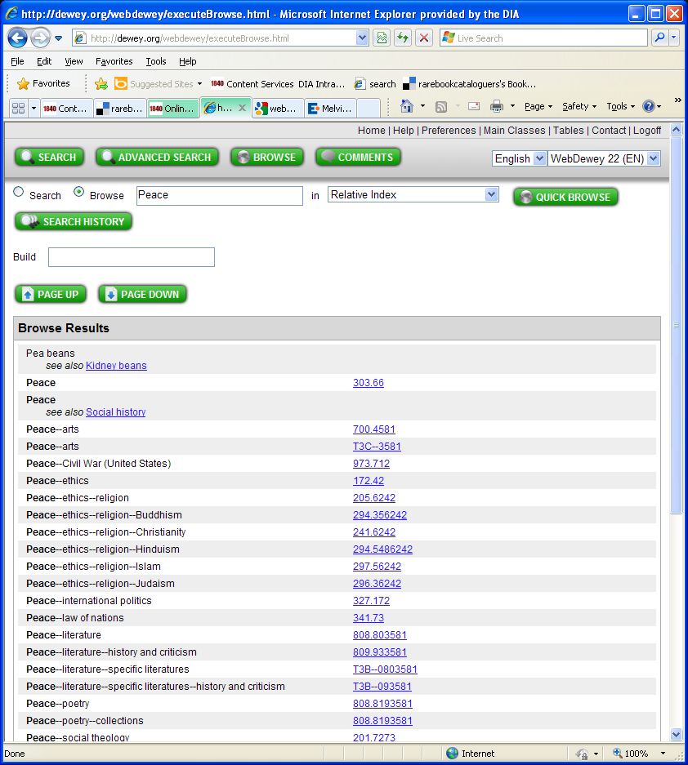

Just as with the print version, you need to consider the discipline and subject of the work, and whether it fits best in social sciences, ethics, politics, law, religion, history etc.

Once you have identified the number, you may be able to add from Table 1 standard subdivisions, or add other numbers as instructed to create the final number.

To begin with, it can be useful to also check the print manual (once you have first chosen a number using WebDewey). Try checking the Relative Index of the print version for “Peace” now.

The Browse option can be useful when checking numbers:

What does this number mean and how was it built: 363.37/65/09/9316
a) Browse 363.37 in Dewey numbers with captions – fire hazards
b) Click on 363.37, and follow note to *Add as instructed under 362-363
c) Right click to open 362-363 in a separate tab. Consider “65 – Investigation of specific incidents”
d) Next, 09 from Table 1 has been added, as the content so far approximates the whole. Right click on Table 1 to open in a new tab
e) Click on 09 - Historical, geographic, persons treatment
f) Click on T1--093-T1—099 Treatment by specific continents, countries, localities; extraterrestrial worlds
g) 9316 from Table 2 is the Whangarei district.

So the number describes the investigation of a fire in the Whangarei District.

E. Review of Search option

The Search option can be useful when you have:

- Very specific keywords

- You’ve found a Library of Congress subject heading that encompasses the work, and you’d like to find the corresponding Dewey number
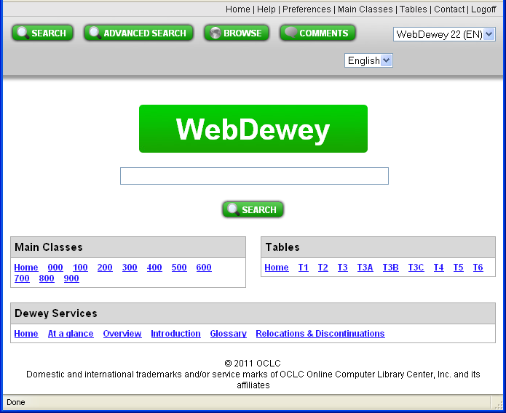
- You already have a base Dewey number, and would like to find a more detailed Dewey number
Use this button!
Not this button!
When you log into WebDewey, you will immediately be presented with a search box that keyword searches all of Dewey. Type keywords in the box, then click on the search button below to activate your search.

There is also a “Search” button at the top right of the screen – however this does not actually initiate searching, it just brings you to the home page “Search” screen.
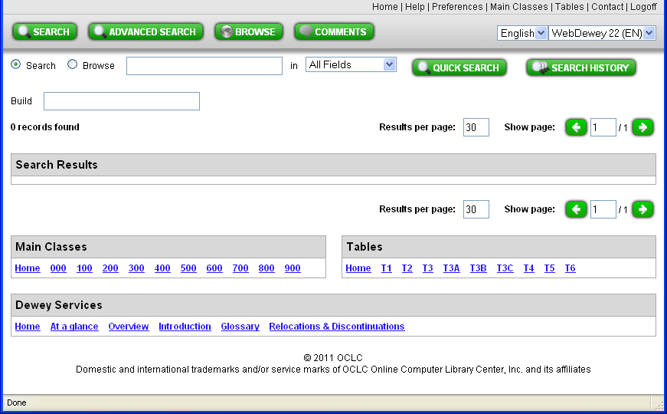
To see more search options, click on the Search button in the middle of the screen. A new “search” screen with more options will appear.

1) The search option is not very useful if you only have quite general keywords. Try doing a search using the keyword “Education” using all of Dewey.

2) Searching “all fields” can be quite useful if you have very specific keywords that may not be present in the relative index.

For example, try searching the relative index for the term “voluntary simplicity movement”.
You will get no search results.

Then try searching “all fields” for the same term.

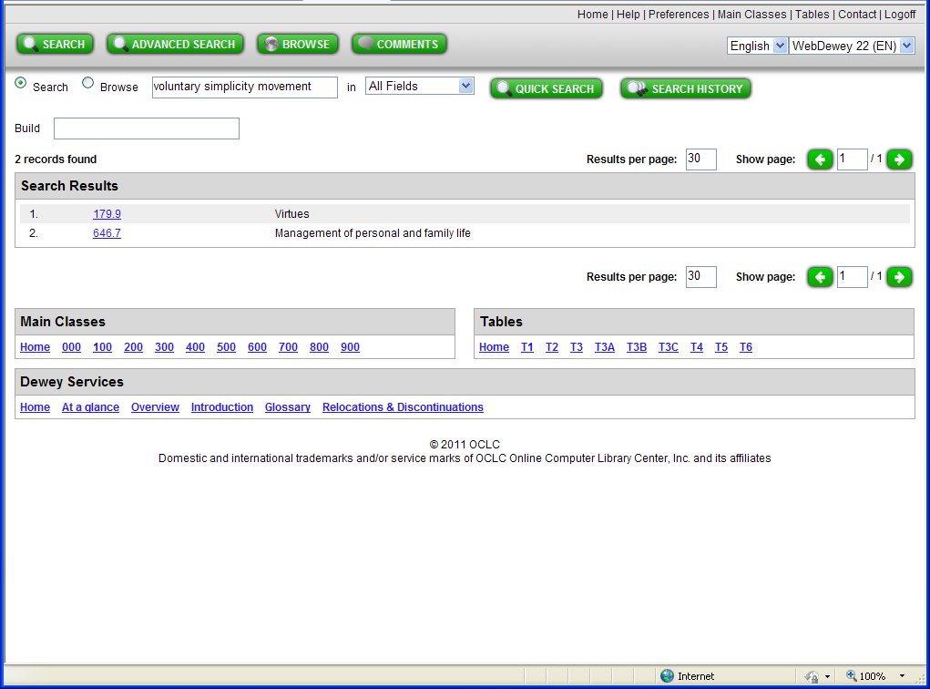

Click on each of the two numbers found to investigate further.

Why did your search of “all fields” find 2 results, while searching the relative index found no results?

You will still need to decide whether the book is about the practical or ethical aspects of the voluntary simplicity movement.

Can you add further from the Tables for either number? Why or why not?

3) The relative index can also help identify geographical subdivisions.

Try searching the Relative index with the word Waimakariri.

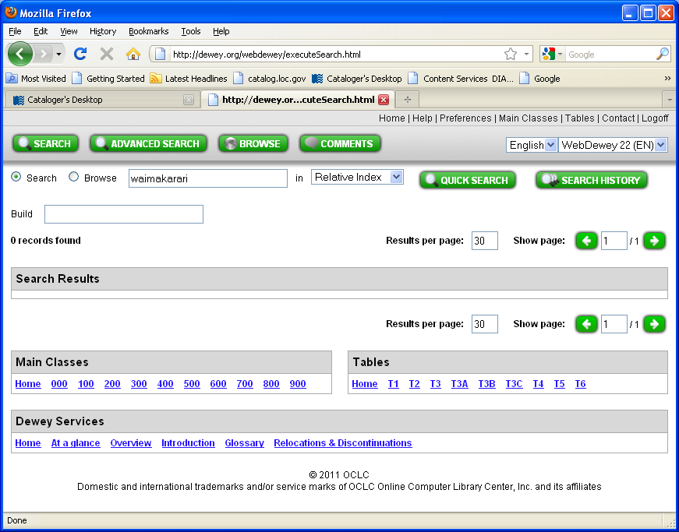

4) To refine your search, click on the Advanced Search button. You will see a screen that allows you to refine your search by restricting it to terms that are in a specific index.

Example: To create a number for the education of Deaf secondary students, you can combine the terms “deaf” and “education”.

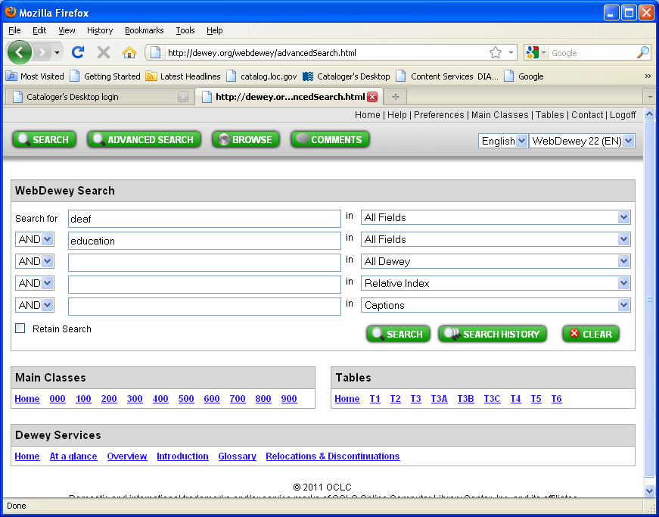

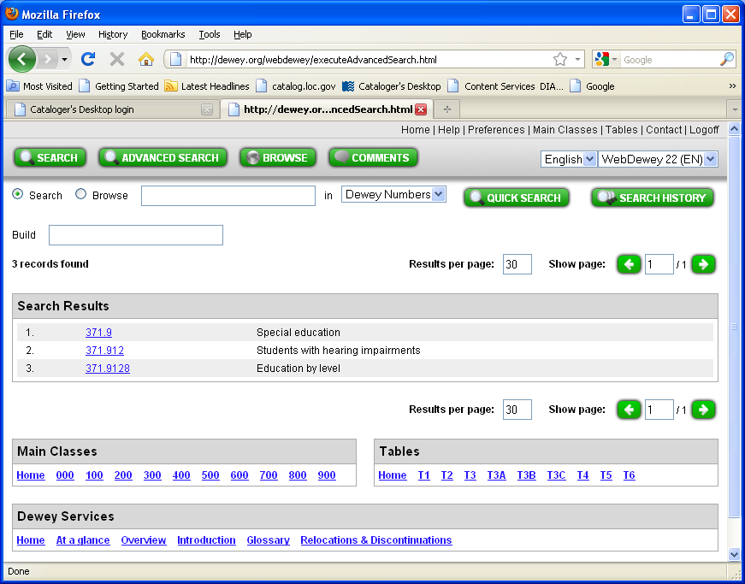

a) Explore each of your search results by clicking further to see the instructions for each number.
- Click on 371.912 – Students with hearing impairments. You will see the note Class here deaf students
- You will see that a narrower number is 371.9218 - Education by level. Click on 371.9218
d) Follow instruction to add numbers following 371.9047 in 371.90472-371.90475
e) Right-click on the Browse button to open in a separate tab. Enter 371.9047 as a Browse search of Dewey Numbers with captions
f) Click on 371.9047 and examine narrower numbers. Special education at secondary level is 371.90473
g) Add 3 to your base number to create 371.92183
F. Using the Tables

The tables are used in exactly the same way that you would in the print version. A straightforward way is to browse through the tables to find the number that you desire.

For example, assume that you are looking to add a subdivision to your base number to indicate “collected persons” treatment in New South Wales i,e, a collective biography.

Open “Table 1” in a new tab, by right-clicking, then “Open in new tab”.

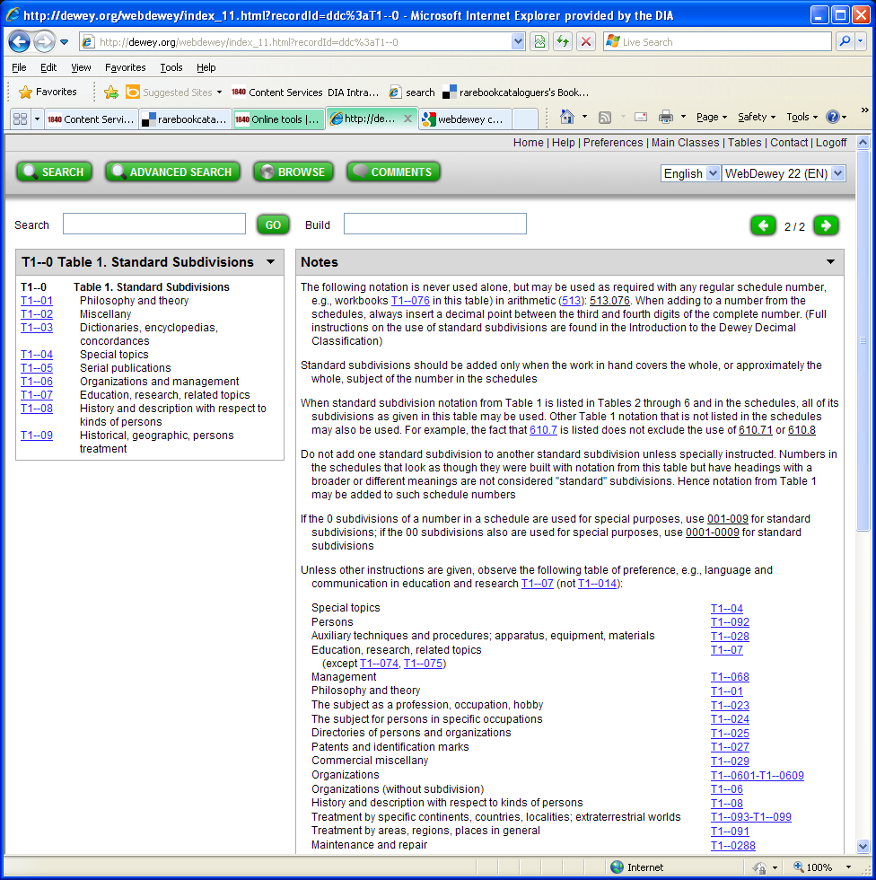

On the right hand side, click on T1--09, then T1—092, then T1—0922.

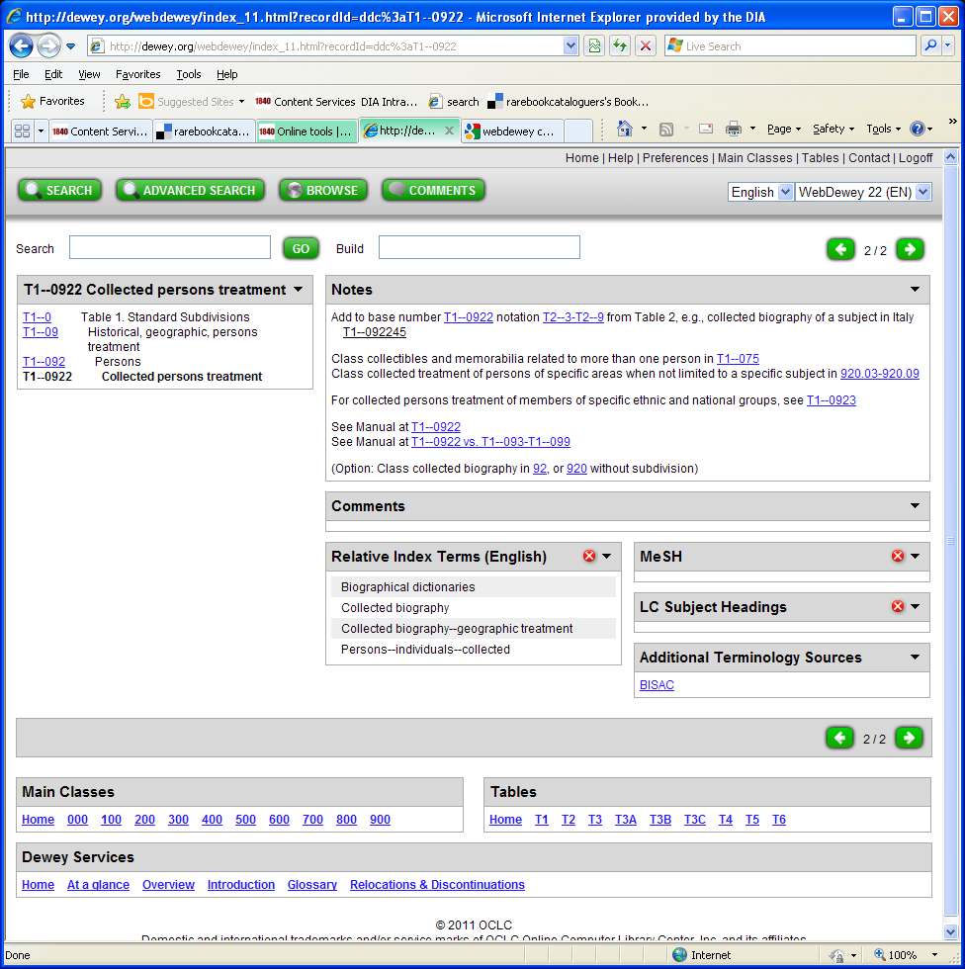

Add to your base number according to the instructions.

Add further from Table 2 to show New South Wales
- Right click on Table 2 to open in a new tab
- Click on T2--3-T2—9 Specific continents, countries, localities; extraterrestrial worlds
- Click on T2--4-T2—9 Modern world; extraterrestrial worlds
- Click on T2—9 Other parts of world and extraterrestrial worlds
- Click on T2--93-T2—96 Australasia and Pacific Ocean islands
- Click on T2—94 Australia
- Click on T2—944 New South Wales

Add 944 to 0922 to create 0922944

You can also use the Search option to find Table subdivisions.

For example, look for the Table 2 subdivision for the Horowhenua district
a) click on the Search button to open the Search screen
b) Enter Horowhenua into the search box, and click on “All Fields” in the drop-down menu. Click on “Quick Search” to activate your search.
c) The geographic subdivision relating to the Horowhenua District will appear – T2--9359

G. Review of “Built” numbers

These are identified in your search results with a “B”.

Example:

a) Click on the Search button to bring up the main Search screen

b) Enter Health education and check the “All fields” option in the drop-down box:

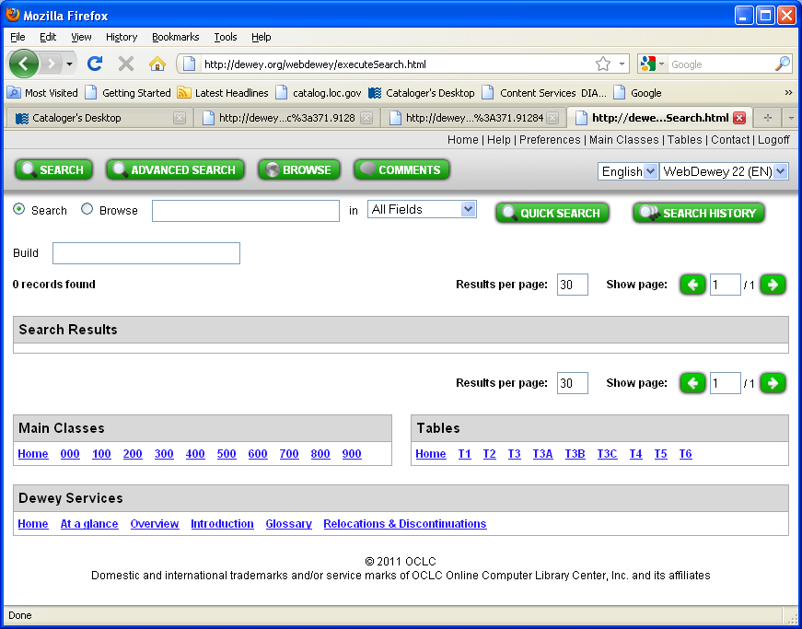

c) Click on “Quick Search”, and then examine your results:

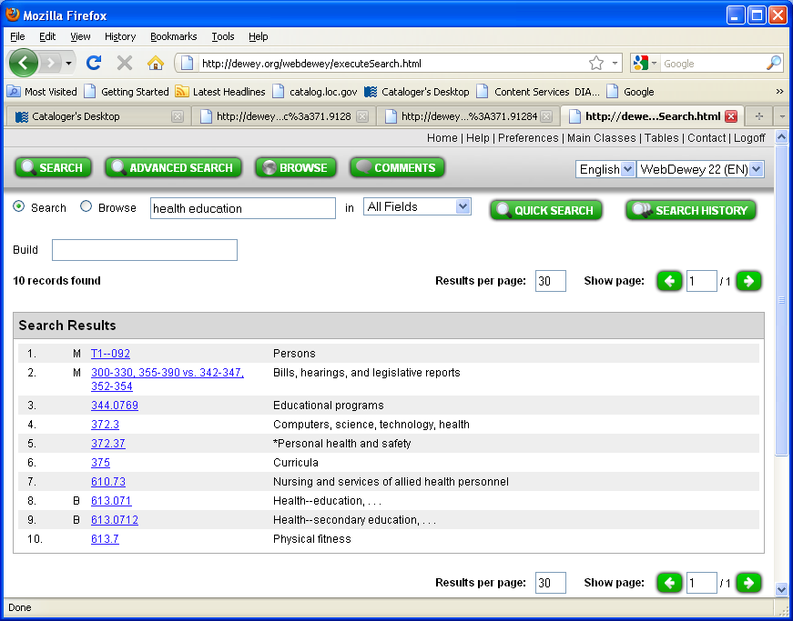

Which numbers are built numbers?

How are they constructed?

- 613.071
- Click on 613.071, then click on the number above it – 613 – Personal health and safety
- Follow instruction that “Standard subdivisions are added for personal health and safety together, for personal health alone”. This allows you to add from Table 1
- Right click on Table 1 to open in a new tab
- Click on T1—07 “Education, research, related topics”
- Click on T1—071 “Education”
- Add to “071” base number to create 613.071, confirming the original number

- 613.0712
- Follow instructions as above, but after clicking on T1—071 “Education”, click on T1-0711-T1-0715 “Specific levels of education”
- Click on T1-0712 “Secondary education”
- Add to base number 613 to create 613.0712, confirming the original number

What does a small “M” in front of “T1—092” mean? Click on T1—092 to read the note in the Manual.

H. Building simple numbers

Example: building a number using the Browse option, and adding according to instructions in the notes and tables.

Consider a work on economic relations between New Zealand and Australia.

- Browse the relative index for the term “Foreign economic relations”

This will take you to the number: 337

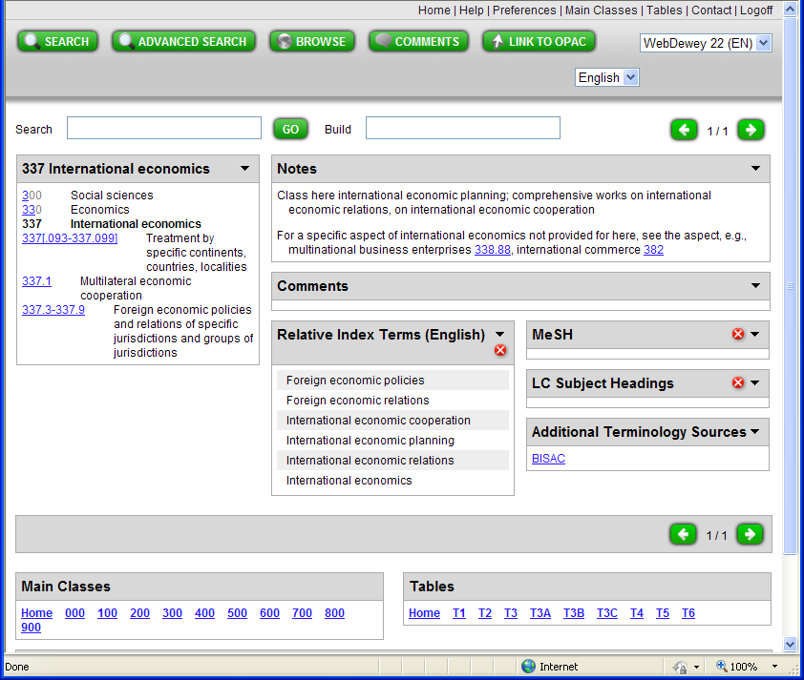

Below the number 337 you will see the range: 337.3-337.9: Foreign economic policies and relations of specific jurisdictions and groups of jurisdictions.

Click on 337.3-337.9

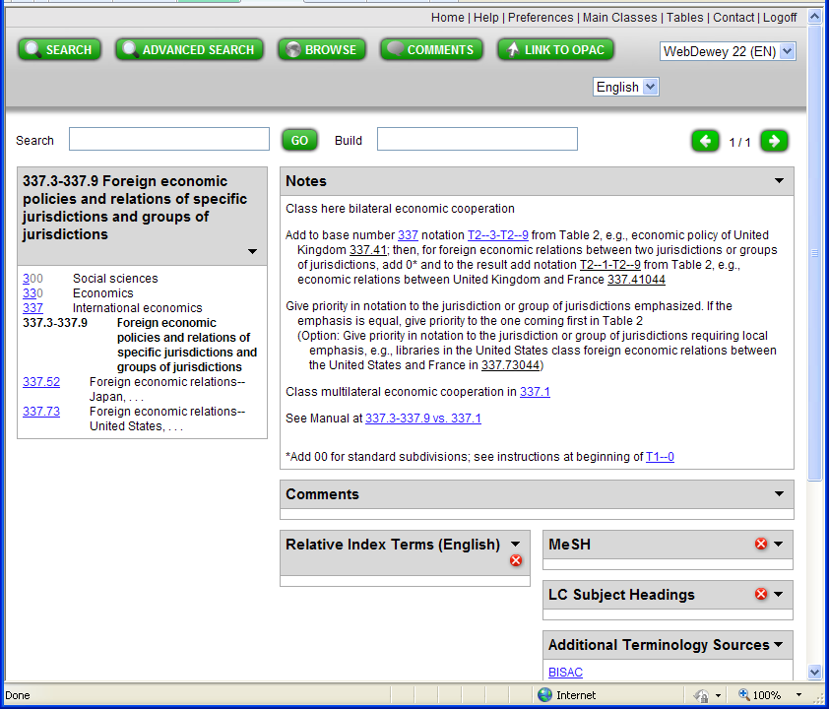

Follow the instructions in the Notes, and add your base number to the “Build” box

Add to base number 337 notation T2--3-T2--9 from Table 2.

In this case, this is New Zealand, so right-click to open Table 2 in a separate tab. Browse to New Zealand “93”.

Add to base number, so you now have: 337.93

Then, for foreign economic relations between two jurisdictions or groups of jurisdictions, add 0* and to the result add notation T2--1-T2--9 from Table 2. Right-click to open Table 2 again, and browse to Australia “94”. Add to the number you are building.

The number is complete: 337.93/0/94

Now, try examining a couple of simple numbers

i) A book about earthquake relief in general

[363.3495/8]

- Open the browse screen by clicking on the Browse button. Select the relative index, and enter “earthquake relief” in the box
- Click on “Quick Browse” to begin your search
- Consider your search results – the interdisciplinary number is first, followed by a law number. Choose the interdisciplinary number 363.34958
- Click on 363.34958
- Look at how this number is constructed. Click on the number above 363.3495 “Earthquakes and volcanoes”. Follow instruction to *Add as instructed under 362-363
- Right-click on 362-363 to open in a new tab
- Examine table – “8” is remedial measures, services, forms of assistance. Relief falls in this category, so add “8” to 363.3495 to confirm the original number – 363.3495/8

ii)A book about forest conservation in New Zealand

[333.75/16/09/93]

- Search “All fields” with the keywords “Forest conservation”
- Examine your results – is it economics or law? Also note that the numbers you see are built numbers
- This is a general work, so click on 333.7516 - Forest lands—conservation
- Check how the number is built, so click on 333.75 – Forest lands. Add 333.75 to the build box
- Follow instruction to *Add as instructed under 333.7-333.9
- Right-click to open 333.7-333.9 in a separate tab
- See that 16 is Conservation and protection, so add 16 to base number to create 333.7516. This confirms the original number
- The instruction under 16 explains that “Standard subdivisions are added for either or both topics in heading”. This allows you to add “09” from Table 1 and then “93” for New Zealand from Table 2
- Open Table 1 (right click to open in separate tab)
- Click on 09 - Historical, geographic, persons treatment
- Click on T1--093-T1—099 Treatment by specific continents, countries, localities; extraterrestrial worlds
- Add 93 from Table 2 for New Zealand

