Resource description for the 21st Century, Monday 13 August, 2018
Dipping into describing works with aggregating and diachronic plans using the new RDA Toolkit

Special sections on Aggregates and Diachronic Works in the 3R RDA Toolkit

- Glossary: Aggregate
A manifestation that embodies an aggregating work and one or more expressions of one or more works that realize the plan for aggregation.

That is, an aggregate embodies more than one expression of one or more works, e.g., two poems, multiple chapters by different authors, a novel with an introduction, a story with added illustrations, etc.

- Guidance: Aggregates and diachronic works: Aggregates
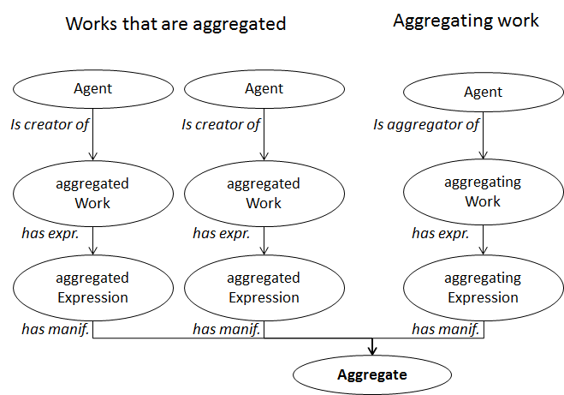
Three types of aggregates:
    - collection aggregate: a manifestation that embodies two or more expressions of two or more independent works
    - augmentation aggregate: a manifestation that embodies two or more expressions of two or more works, where one work is supplemented by one or more other works
    - parallel aggregate: a manifestation that embodies two or more expressions in different languages or scripts of a single work

- Glossary: Diachronic work
A work that is planned to be embodied over time.

- Guidance: Aggregates and diachronic works: Diachronic works
Two types of diachronic works
    - Glossary: Integrating work
A diachronic work that is planned to be realized in a single expression.
    - Glossary: Successive work
A diachronic work that is planned to be realized in multiple distinct expressions.
      - Glossary: Serial work:
A successive work that is planned to be realized in multiple distinct aggregating expressions over an indeterminate timespan.

  - Guidance: Resource description: Describing a work:
    - Describing an aggregating work
    - Describing a work that is aggregated
    - Describing a diachronic work
    - Work: extension plan

integrating determinate plan | An extension plan for a work that is intended to be realized in one distinct expression that is embodied during a closed timespan.
 | Scope Note: Includes project wikis, and conference websites.
integrating indeterminate plan | An extension plan for a work that is intended to be realized in one distinct expression that is embodied during an open timespan.
 | Scope Note: Includes updated standards, laws, and wikis.
static plan | An extension plan for a work intended to be realized in one or more distinct expressions that are all embodied simultaneously.
 | Scope Note: Includes poems, photographs, and completed novels.
successive determinate plan | An extension plan for a work that is intended to be realized in multiple distinct expressions that are embodied during a closed timespan.
 | Scope Note: Includes serialized versions of novels, dictionaries, and reference works.
successive indeterminate plan | An extension plan for a work that is intended to be realized in multiple distinct expressions that are embodied during an open timespan,
 | Scope Note: Includes periodicals, newspapers, series, newsletters, conference proceedings, annual reports, and archived copies of webpages.
 | Synonyms: serial work plan

  - Guidance: Resource description: Describing an expression:
    - Describing an aggregating expression
      - Expression: aggregates
    - Describing an expression that is aggregated
      - Expression: aggregated by
  - Guidance: Resource description: Describing a manifestation:
    - Describing a manifestation that embodies more than one expression
    - Manifestation: mode of issuance

multiple unit | A mode of issuance of a manifestation that is issued as a multipart physical unit or intangible multipart logical unit.
single unit | A mode of issuance of a manifestation that is issued as a single physical unit or intangible single logical unit.  Scope Note  A single volume, a file available online, etc., are included.

    - Manifestation: contributor to aggregate

- Provenance data:
  - Recording a scope for validity of metadata
  - Recording a timespan for validity of metadata

Describing a work that is aggregated | Describing an aggregating work
Record elements that are appropriate for the work that is aggregated | Record elements for the aggregating work (characteristics of the works that are aggregated)
Use note on work for any aggregating works | Use note on work for works that are aggregated
No direct relationship to any aggregating works (except for aggregating works that are successive) | No direct relationship to works that are aggregated (except for aggregating works that are successive)
- if the work that is aggregated is static, use issue of for its successive aggregating work | - if the aggregating work is successive, use issue for an aggregated work that is static
- if the work that is aggregated is, itself, a successive aggregating work, use subseries of for its successive aggregating work | - if the aggregating work is successive, use subseries for a work that is aggregated when it is, also, a successive aggregating work
Use related agent of work (or a sub-property) for agents related to the work that is aggregated | Use aggregator for creators of aggregating works
No direct relationship to agents related to any aggregating works | No direct relationship to agents related to works that are aggregated
WE lock applies only if aggregated is also aggregating | WE lock applies
Describing an expression that is aggregated | Describing an aggregating expression
Record elements that are appropriate for the expression that is aggregated | Record elements for the aggregating expression (characteristics of the expressions that are aggregated)
Use note on expression for any aggregating expressions | Use note on expression for expressions that are aggregated
Use aggregated by for an aggregating expression | Use aggregates for an expression that is aggregated
Use related agent of expression (or a sub-property) for agents related to the expression that is aggregated | Use related agent of expression (or a sub-property) for agents related to the aggregating expression
No direct relationship to agents related to any aggregating expressions | No direct relationship to agents related to any expressions that are aggregated
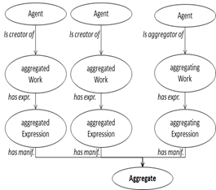 | Describing an aggregate manifestation
 | Record elements appropriate for the aggregate
 | Record a value for Mode of issuance
 | Use note on manifestation for embodied expressions
 | Use expression manifested for an aggregating expression
 | Use expression manifested for an expression that is aggregated
 | Use contributor to aggregate for a creator of a work that is aggregated

Describing a diachronic work
Record elements for the diachronic work (characteristics of its part, issue, or iteration works)
Record a value for Extension plan
Record changes to Work element data over time
Record provenance data to indicate the timespan or scope of validity for Work element data
WEM lock applies
Describing an expression of a diachronic work
Record elements for the diachronic expression (characteristics of its part, issue, or iteration expressions)
Record changes to element data over time
Record provenance data to indicate the timespan or scope of validity for Expression element data
Describing a manifestation that embodies a diachronic work
Record elements for the diachronic manifestation (characteristics of its part, issue, or iteration manifestations)
Record changes to element data over time
Record provenance data to indicate the timespan or scope of validity for Manifestation element data

