LIANZA Standing Committee on Freedom of Information

The LIANZA Standing Committee on Freedom of Information is calling you….
Whakahoki kōrero mai

The LIANZA Standing Committee on Freedom of Information has begun to review and update position statements to support LIANZA and its members to be knowledgeable and confident regarding freedom of information issues.

LIANZA Council just approved a new draft statement on Freedom of Information to be circulated for final feedback from members and other interested parties.

LIANZA’s regional and special interest committees have been asked to discuss and comment, as have PLNZ, NZLLA and Te Rōpu Whakahau. Individual members are also encouraged to send comments to Freedom@lianza.org.nz before 10 January 2020 and the statement will then be finalised and published.

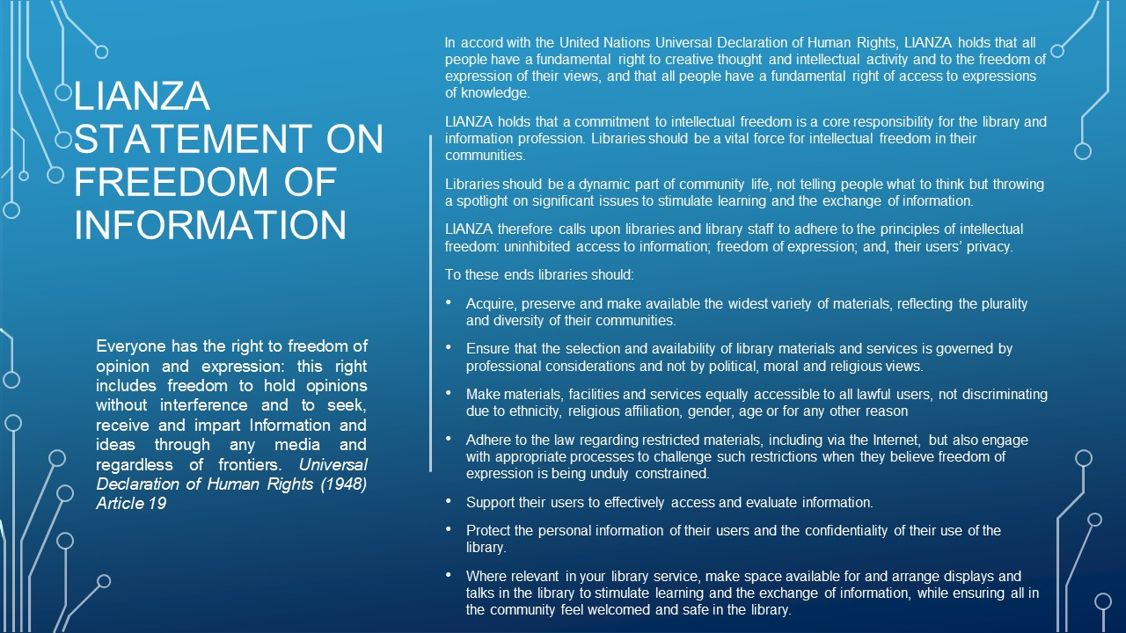

Everyone has the right to freedom of opinion and expression: this right includes freedom to hold opinions without interference and to seek, receive and impart Information and ideas through any media and regardless of frontiers. Universal Declaration of Human Rights (1948) Article 19

In accord with the United Nations Universal Declaration of Human Rights, LIANZA holds that all people have a fundamental right to creative thought and intellectual activity and to the freedom of expression of their views, and that all people have a fundamental right of access to expressions of knowledge.

LIANZA holds that a commitment to intellectual freedom is a core responsibility for the library and information profession. Libraries should be a vital force for intellectual freedom in their communities.
Libraries should be a dynamic part of community life, not telling people what to think but throwing a spotlight on significant issues to stimulate learning and the exchange of information.
LIANZA therefore calls upon libraries and library staff to adhere to the principles of intellectual freedom: uninhibited access to information; freedom of expression; and, their users’ privacy.

To these ends libraries should:
- Acquire, preserve and make available the widest variety of materials, reflecting the plurality and diversity of their communities.
- Ensure that the selection and availability of library materials and services is governed by professional considerations and not by political, moral and religious views.
- Make materials, facilities and services equally accessible to all lawful users, not discriminating due to ethnicity, religious affiliation, gender, age or for any other reason
- Adhere to the law regarding restricted materials, including via the Internet, but also engage with appropriate processes to challenge such restrictions when they believe freedom of expression is being unduly constrained.
- Support their users to effectively access and evaluate information.
- Protect the personal information of their users and the confidentiality of their use of the library.
- Where relevant in your library service, make space available for and arrange displays and talks in the library to stimulate learning and the exchange of information, while ensuring all in the community feel welcomed and safe in the library.

This is a high-level statement which will be supported by more detailed guidelines on specific topics such as censorship, privacy and indigenous knowledge. These are yet to be completed or in some cases started. The LIANZA Standing Committee on Freedom of Information need some more help to keep working on these, so…..

Tautoko mai

The committee is looking for one-two members of LIANZA or Te Rōpū Whakahau to join the LIANZA Standing Committee on Freedom of Information. The committee exists to provide advocacy, resources and guidelines to support LIANZA Council and LIANZA members and to share communications about new resources or emerging issues. We are currently working to update LIANZA position statements drawing on previous and international documents including from IFLA and the United Nations.

The committee meets by Zoom once a month for an hour, with work between meetings. Expected time commitment is around 5-10 hours per month, and the initial commitment for membership is a three-year term.

We invite anyone interested to send your EOI and CV to ana@lianza.org.nz by Monday December 16th

If you have any questions about the standing committee please contact Louise LaHatte, the current chair on: freedom@lianza.org.nz

