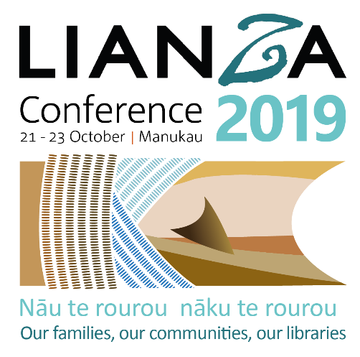
Abstract Submission Support Document
Well done on taking the step to submit an abstract submission to present at the 2019 LIANZA Conference. This document will help guide you through the submission process and provide support in preparing the information required for your submission.
If at any time you would like to talk to someone about your submission, contact the Conference Organisers, Paardekooper and Associates on 04 562 8259 or email hayley@paardekooper.nz.
All submissions are to be entered through our online abstract system.
Step 1: Set up a profile
To start, you will need to set up a profile. Click on “New User?”
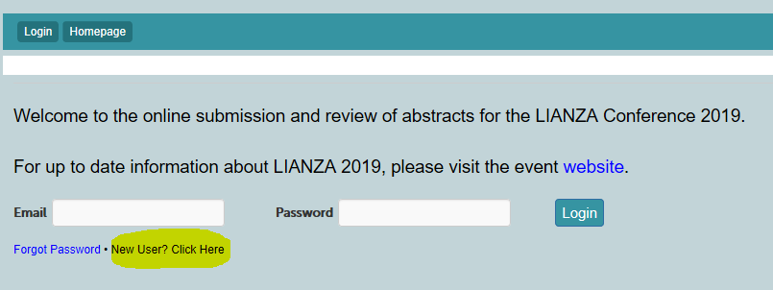
The following fields are required to set up your profile:
- Email address
- Password
- Title (Mr, Mrs, Miss etc)
- First Name
- Last Name
- Position
- Organisation
- Work phone
- City
- Country
- Biography (max 300 words)
- Profile photo
- Whether you have presented at LIANZA before
Step 2: Preparing your abstract submission
We recommend preparing your submission on a word document first and then copy and paste into the submission system. You can use the following template to prepare your submission:

Abstract Submission Template
Audience (Submission Group) – select one
- Academic Librarians
- Public Librarians
- School Librarians
- Special Librarians (GLAM, law, health etc)
Presentation format – select one
- Lightning talk - 10 mins
- Panel - 100 mins
- Paper - 30 mins
- Poster - during a lunch break
- Workshop - 65 mins
Presentation title (10 words max) – this will be shown in the programme timetable, so think of something catchy to attract attendees to come and listen to your presentation!

Full Abstract (300 words max) – the full abstract is to assist with the reviewing and scoring of your presentation, to determine whether it meets the criteria. The criteria that abstracts will be scored against is shown below.

Summary Abstract (150 words max) – the summary abstract will be used in the handbook/app to promote your presentation.

Keywords/Tags – think of 4 words that best describes the content of your presentation. Keywords will be used to assist with timetabling your presentation and will be published alongside your summary abstract to assist attendees when selecting what presentations they want to go to.

File Upload – This is only required if your abstract contains macrons or special characters. We’ll get you to upload your full abstract and summary abstract as a file upload. This is because the system sometimes loses the macrons or special characters when exporting date. Please upload using one of the following file types: .doc; .docx; .pdf; .rtf; .txt

Availability to present - Monday 21, Tuesday 22 or Wednesday 23 October – this question is to assist with timetabling; let us know your availability:
- I am available to present on all dates
- I am only available on Monday 21 October
- I am only available on Tuesday 22 October
- I am only available on Wednesday 23 October

Step 3: Create an online submission
Click on the Submissions tab and click “add new” to start! Complete the fields.
If you want the ability to go back in and edit, make sure you click “Save & continue later”. You will be able to go back into your submission and make changes up until the close date Wednesday 20 March 2019, 11:59pm (NZ time)
If you are ready to finalise your submission, click “Save & submit”. Warning, you will not be able to go back and edit once you save & submit!
An email will be sent to you confirming your submission has been created.

Evaluation of abstracts
Your submission should answer these questions:
- What are the issues the paper and/or presentation highlights/addresses/raises?
- Why are these issues significant?
- How do these issues relate to the conference theme?
- What contributions might this paper and/or presentation make to the library and information sector?
- What are the implications for the future?

Abstracts will be evaluated by the LIANZA 2019 Programme Committee against the following criteria:
- Appropriateness and significance of the topic to the conference theme
- Originality, significance (is this a new and original contribution?)

Do not include information in your abstract that will not be included in your presentation.

Need help?
If you need help with your submission at any stage please contact the Conference Organisers, Paardekooper and Associates:
Phone + 64 4 562 8259
Email hayley@paardekooper.nz

